3.5 OneLake integration for eventhouse & semantic models

Key points
- In the Eventhouse, you have a setting called OneLake availability, which when you turn it on, means that you can query the data in your KQL database in Delta Lake format via other Fabric engines such as Direct Lake mode in Power BI, Warehouse, Lakehouse, Notebooks, and more.

- The details of this are as follows:
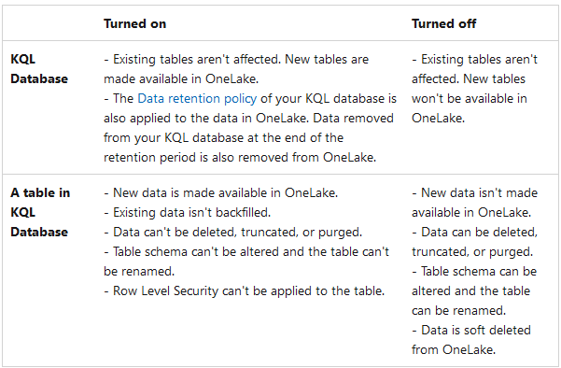
You can turn on OneLake availability either on a KQL database or table level.
- To turn on OneLake availability, browse to the OneLake section in the details pane of your KQL database or table.

- Set Availability to On.
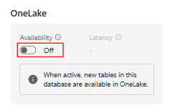

- The database refreshes automatically.
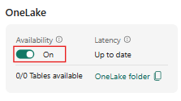

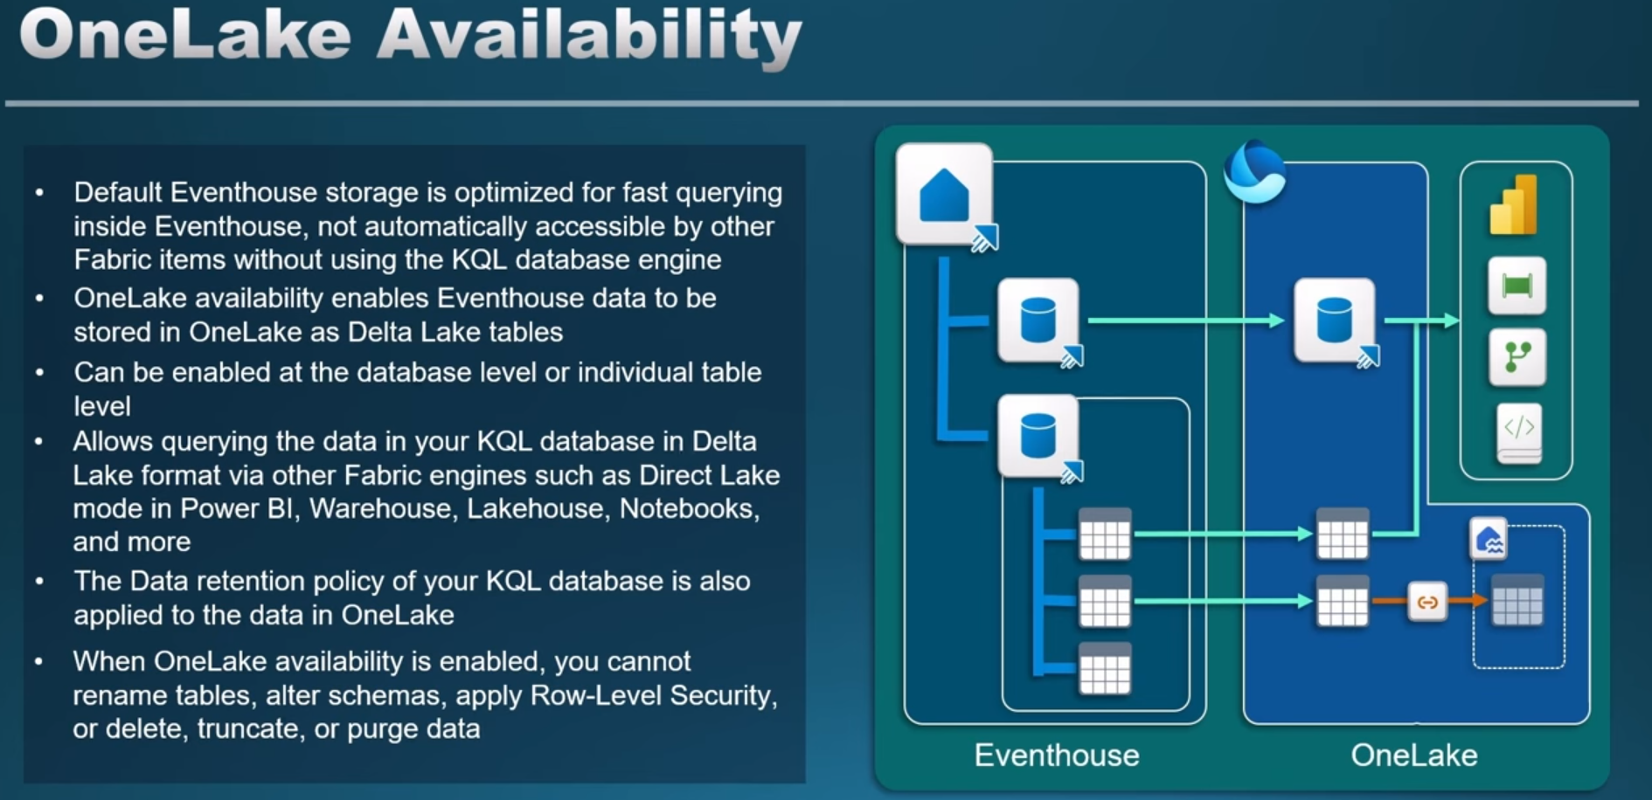
You turned on OneLake availability in your KQL database. You can now access all the new data added to your database at the given OneLake path in Delta Lake format. You can also choose to create a OneLake shortcut from a Lakehouse, Data Warehouse, or query the data directly via Power BI Direct Lake mode.

Licensing (supported SKUs for this feature “OneLake integration for eventhouse & semantic models”):
- Power BI Premium P SKU
- Microsoft Fabric F SKU

- Also, you need to have the large format semantic model enabled, as well as have at least the contributor role to set this up.

